**ENUM**

* an enum (short for enumeration) is a special data type that allows you to define a **collection of constants.**
* Enums are useful for representing a fixed set of related values, such as days of the week, states in a process, or categories of items.

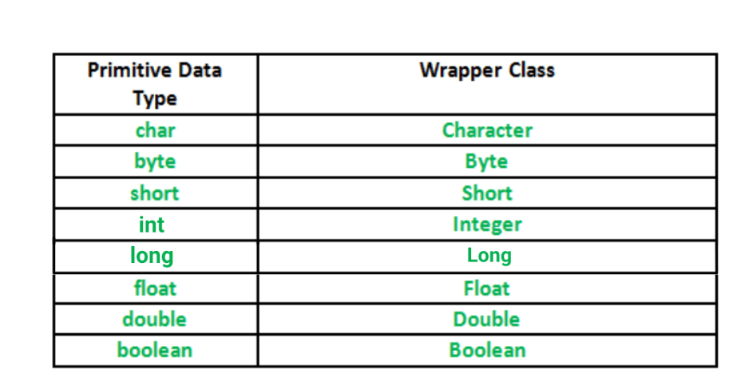

* Using valueOf() -> String to Wrapper -
* using parseXO(); ->. String to Primitive
* Wrapper Object to String-> toString()

**Real usage will come in Collection Framework.**